
Task # 01
Name : Nabiha Sabir
Roll no : bssem-s24-019
Section :5A
Subject :Computer Network lab
Submitted to : mam

Q1: How to Download Cisco Packet Tracer + Screenshot

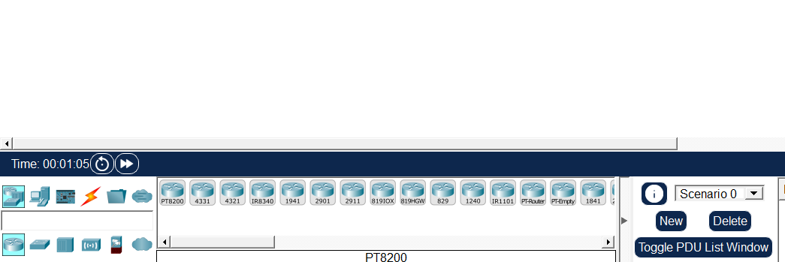

Q2: What is Cisco Packet Tracer? Why we use it?
Cisco Packet Tracer is a network simulation software used to design and test computer networks without real hardware.
Why we use it:
- To practice networking without buying expensive devices
- To simulate routers, switches, and connections
- To learn CCNA concepts
- To test network designs before real implementation
Q3: Difference between Routers (in Packet Tracer)
In Packet Tracer, you’ll see routers like:
- 1941 Router
- 2911 Router
- 4321 Router
- Generic Router
Differences:
- Ports (interfaces): Some routers have more Ethernet/Serial ports
- Performance: Higher models handle more traffic
- Modules: Some support extra cards (WAN, serial, etc.)
When to use:
- 1941 → Basic labs (best for beginners)
- 2911 → Medium networks
- 4321 → Advanced/modern networks
- Generic → Simple practice

Q4: Difference between Switches
Common switches in Packet Tracer:
- 2960 Switch
- 3560 Switch
- Generic Switch
Differences:
- Layer 2 vs Layer 3
  - 2960 → Layer 2 (basic switching)
  - 3560 → Layer 3 (routing + switching)
- Features
  - VLAN support
  - Routing capability (only in Layer 3)
When to use:
- 2960 → VLANs, basic networks
- 3560 → Inter-VLAN routing
- Generic → Simple practice

Q5: Difference between Connection Wires
In Packet Tracer:
Types of cables:
- Copper Straight-Through
  - Use: Different devices
  - Example: PC → Switch
- Copper Cross-Over
  - Use: Same devices
  - Example: Switch → Switch
- Fiber Cable
  - Use: High-speed connections
- Serial Cable
  - Use: Router to Router (WAN)
- Console Cable
  - Use: PC → Router (for configuration)

